

|  |
| --- |
| **MATHEMATICS DEPARTMENT**  **Year 11 Specialist – 2016**  **Test Number 3:**  **Counting Techniques and Vector Applications**  **Resource Free** |

Total Mark

/47

**Name: _______________________________________ Teacher: DDA**

**Marks: 22**

**Time Allowed: 20 minutes**

**Weight: 5%**

**Instructions:** You **ARE** **NOT** permitted any notes or calculator. Show your working where appropriate remembering you must show working for questions worth more than 2 marks.

_________________________________________________________________________

1 A product code consists of 4 characters, each of which may be the digits 1–9 or the letters A, B and C.   
The number of possible product codes is

A 34 × 94

B  12 × 11 × 10 × 9

C  9P3

D 9C3

E 124

[1 mark]

2 A Year 8 student making course selections for Year 9 has the choices shown below:

Compulsory: English, Maths, Science and PE

Choice 1: Music, Art, History, Economics, Health, Business practices

Choice 2: Sewing, Cooking, Home Economics, Metalwork, Woodwork, Workshop

Choice 3: Geography, Computer Studies, French, German, Chinese

The number of different possible courses is:

A 184

B 720

C 180

D 252

E 216

[1 mark]

3 A family has 5 children. What is the probability of guessing the exact sequence of boys and girls in the family?

A 

B 

C 

D 

E 

[1 mark]

4 The 24 people on a bus have black, brown, red, blonde, grey, pink and green hair. Obviously some are dyed, but how many people must get off at the same stop for you to be sure that two of those who get off have the same hair colour?

A 7

B 8

C 12

D 24

E 14

[1 mark]

5 The projection of m = (4, 60°) on n = (10, 240°) is:

A 4

B 10

C −4

D 0

E −10

[1 mark]

6 An airplane is flying toward the north-west. Which of the following wind velocity vectors, where i is east and j is north, increases the plane’s speed the most?

A w1 = i + 5j

B w2 = −5j

C w3 = 5i + j

D w4 = 5i − j

E w5 = −i + 5j

[1 mark]

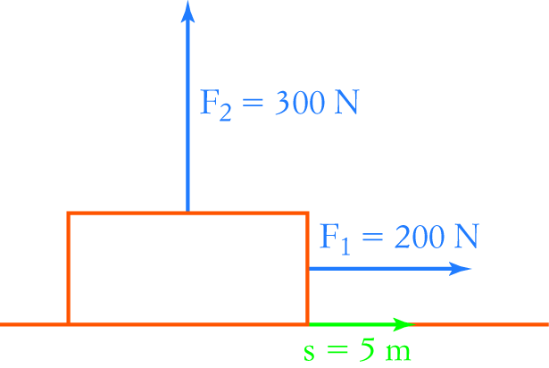7 An object is subjected to two forces as shown in the diagram   
on the right. If the object has a displacement of 5 m, then the   
work done by the forces is:

A 1000 J

B 0

C 1500 J

D 2500 J

E 500 J [1 mark]

8 How many people do you need to be sure of having 3 with their birthday on the same day of the month?   
They can be in different months.

[2 marks]

9 The angle between vectors a and b is θ. Find a **⋅** b when:

|a| = 6, |b| = 10 and θ = 120°

[2 marks]

10 Calculate the scalar product of the following pair of vectors.

14i − 7j and 12i + 24j

[1 mark]

11 Determine if the following pairs of vectors are perpendicular, parallel or neither.

a (−4, −3) and (2, −7)

b (−3, 1.5) and (6, −3)

c (5, 1) and (1, −5)

[3 marks]

12 A school theatre does not have any windows so that performances can use proper theatre lights during the day. During lunchtime rehearsal, all the lights go out while there are 10 people in the theatre.   
As a result they come out at random. What is the probability that Andrew, Mona and Simone come out together, with Andrew between the two girls?

[3 marks]

13 Prove that n! can be obtained from the alternative recursive rule that n! = (n − 1)[(n − 1)! + (n − 2)!],   
where 0! = 1! = 1.

[4 marks]



|  |
| --- |
| **MATHEMATICS DEPARTMENT**  **Year 11 Specialist – 2016**  **Test Number 3:**  **Counting Techniques and Vector Applications**  **Resource Rich Section** |

**Name: _______________________________________ Teacher: DDA**

**Marks: 25**

**Time Allowed: 25 minutes**

**Weight: 5%**

**Instructions:** 1 A4 page of notes allowed. Calculators allowed. Show your working where appropriate remembering you must show working for questions worth more than 2 marks.

_________________________________________________________________________

14 How many different anagrams of the word EXCESSIVE are there?

A 30 240

B  362 880

C  60 480

D 40 320

E   90 720

[1 mark]

15 In how many different ways can 8 different people be arranged in a circle?

A   20 160

B 10 080

C 362 880

D 5040

E  40 320

[1 mark]

16 How many 4 letter ‘words’ can be made from the letters of ENDORSE at least one letter must be a vowel. Three vowels are not allowed, and no letters may be used more than the number of times they appear in ENDORSE.

[4 marks]

17 Calculate the angle between (2, 4) and (−7.5, 12).

[3 marks]

18 Find the projection of p = (8, 6) on q = (2.5, 6).

[3 marks]

19 Calculate the work done in each of the following situations.

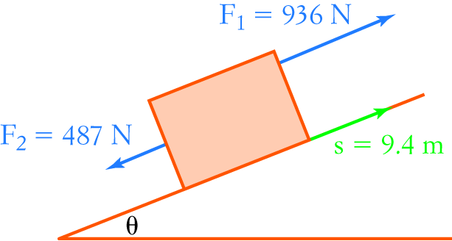

[2 marks]

20 A car going up a hill inclined at 15° has a weight of 7800 N acting vertically downwards.   
Resolve the weight into components parallel and perpendicular to the slope.

[3 marks]

21 A yacht makes 12 knots ‘through the water’ and sails at a bearing of 242°. There is a strong current of 5 knots towards the south. What are the actual bearing and speed of the yacht?

[4 marks]

22 Three ropes attached to a metal ring are being pulled by different people. Lucy is exerting a force of 200 N, and Gary is exerting a force of 250 N at an angle of 150° to Lucy. What force must Penelope be exerting if the ring does not move?

[4 marks]